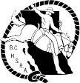
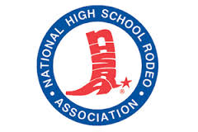
BC HIGH SCHOOL RODEO ASSOCIATION
MEMBERS OF NATIONAL HIGH SCHOOL RODEO ASSOCIATION

PROPOSAL

2014/15 HIGH SCHOOL RODEO FINALS

DATES:_____________________________ LOCATION:___________________________________________

FINALS COMMITTEE:________________________________________________________________________________

FACILITIES:___________________________________________________________________________________________

COSTS:___________________________________

CAMPING/STALLS:___________________________________________________________________________________

COSTS:________________________________________

ADDITIONAL INFORMATION:_______________________________________________________________________

___________________________________________________________________________________________________________

___________________________________________________________________________________________________________

VENUES:

GRAD BANQUET AREA:________________________________________COSTS:______________________

SCHOLARSHIP AREA: __________________________________________COSTS:______________________

QUEEN COMPETITION: ________________________________________COSTS:______________________

PROPOSAL DEADLINE – NOVEMBER 10/14
EMAIL TO: bchsrasecretary@gmail.com

