DON’T FORGET TO
CHECK OUT THE BOOTHS OF SOME OF OUR AMAZING SPONSORS
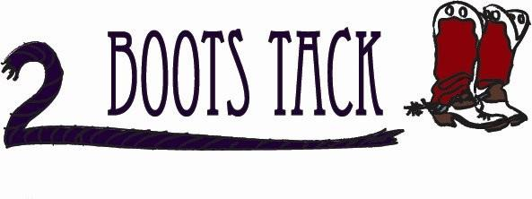
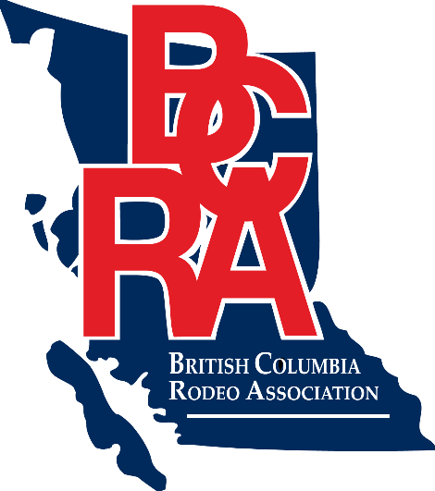
Get your tickets now for a chance to win a new Polaris!!

ONSITE REPAIRS FOR REASONABLE PRICES ANDGET YOUR NAME IN A DRAW FOR A CUSTOM BASKET STAMPED BELT VALUED AT $150
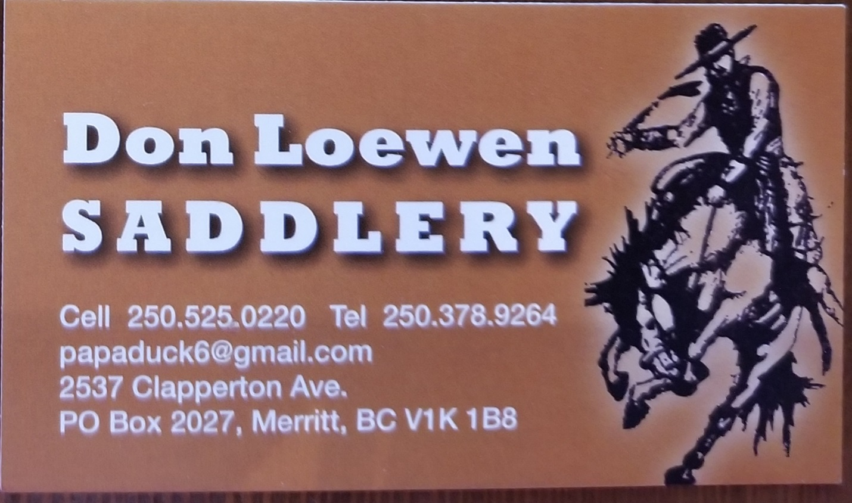
CONTESTANTS! MAKE SURE TO STOP BY THE COWBOY’S CHOICE BOOTH TO ENTER A DRAW!
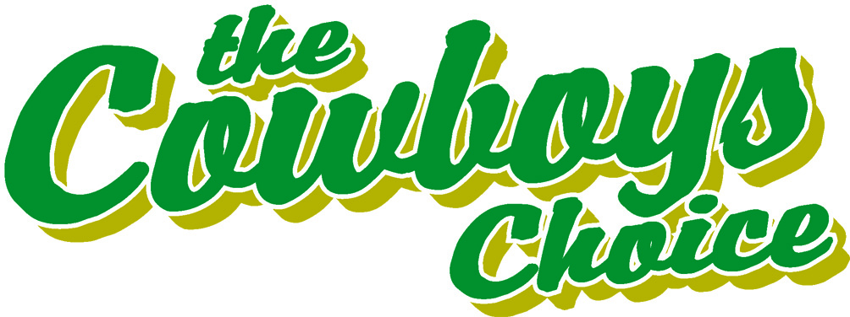

CHECK OUT MORE VENDORS
GYLDIS PIZZA ~ FOR THEIR
YUMMY BREAKFAST SANDWHICHES
OGOPOGO DONUTS
BLENDER BENDER

